My ZonMw manual

For reviewers

August 8 2025



Contents

Introduction 3
1 Logging in 4
1.1 Activating your account 4
1.2 Logging in as an existing user 4
1.3 Resetting your password 4
1.4 Select language 5
2 Inbox 5
3 Assessment of grant applications 6
3.1 Assessment form: overview and completion 6
3.2 Saving an assessment form 8
3.3 Submitting an assessment form 9

Introduction
ZonMw uses the My ZonMw system for assessing grant applications. This manual is intended for reviewers and contains instructions on how to activate an account, change language settings and enter personal details in My ZonMw. It also explains how to assess applications.

In case of substantive questions, please contact the programme manager of the relevant funding round. If you have any technical questions you can contact the ZonMw Service desk (at servicedesk@zonmw.nl or on +31 70 349 51 78).

1 Logging in

1.1 Activating your account
If you are logging in to My ZonMw for the first time, you must first activate your account. You will have received a message from the Programme Bureau indicating which email address has been used to create an account for you.
- As a new account has been created for you, we will ask you to first reset your password. You can go to My ZonMw via the following link: Reset-password
- Please enter your email address to reset your password (ZonMw will have informed you of the correct email address).
- You will then receive an email at this email address from no-reply@zonmw.nl containing a link to set a new password.
- Please bear in mind that in My ZonMw, only passwords of at least 12 characters are possible and they must include 1 number, 1 1 upper or lower case character and 1 special character. You can use Norton Password Creator to help you create a password the system will accept.
- You can then use the password generated to activate your account. Remember to store your password in your browser or a password manager for later sessions.

1.2 Logging in as an existing user
If you have logged into My ZonMw before, you can log in with your email address and password (Figure 1).
- Log in as an existing user by entering your ‘Email – E-mail’ and ‘Password – Wachtwoord’ and clicking on .
Please note: It is possible that you have multiple accounts. Therefore, look carefully in the invitation at the email address used to invite you. If you do not see a task in your inbox, you may have logged in with a different account than the one indicated in the invitation.
- If you have forgotten your password, click on ‘Forgotten your password?’

Please note: If you enter your password incorrectly five times in succession, your account will be locked. In that case, you can send an email to servicedesk@zonmw.nl with the request to unlock your My ZonMw account.

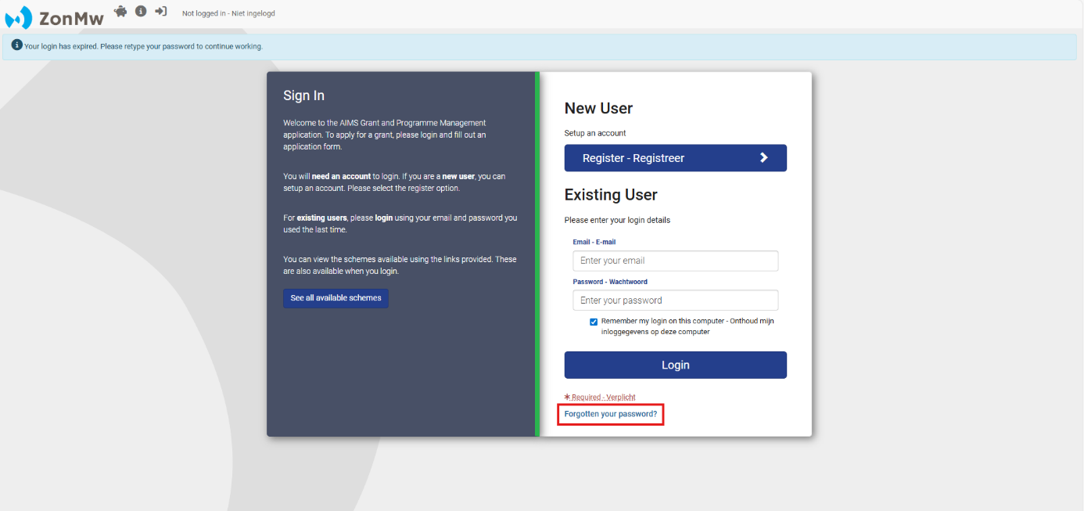
Figure 1: Logging in as an existing user and forgotten your password.

1.3 Resetting your password
If you have forgotten your password, you can reset your password (Figure 2):
- Enter your email address at ‘Email’.
- Then click on the button.

You will receive an email with a link to create a new password.
Please note: If you did not receive an email, please check your junk email / spam folder.

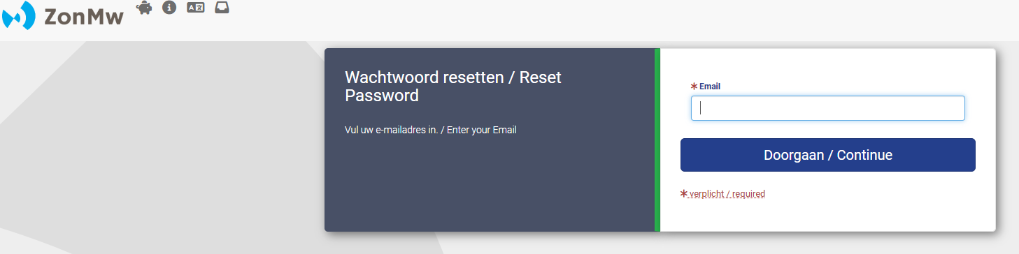
Figure 2: Resetting your password.

1.4 Select language
When you log in for the first time, My ZonMw is set to English. You can change the language to Dutch by clicking on at the top of the menu bar after you have logged in (Figure 3).
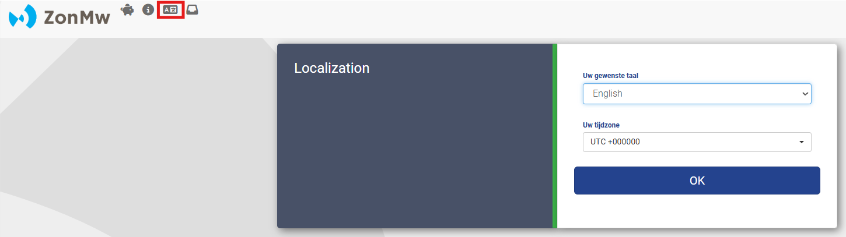
Figure 3: Select language.

2 Inbox
After logging in, you will automatically be directed to your inbox (Figure 4).

Here you will see an overview of ‘Upcoming Tasks’ and ‘My Applications’. A task is, for example, communicating personal interests and assessing an application. Once you have completed a task, you will find the file under ‘Applications I Am Linked To’. You can also see here what you have already submitted.
- To start in My ZonMw, first click on ‘Edit My Details’ (1) to change your contact details. Please note: it is not possible to change your middle name, last name and email yourself. Changes can be requested by sending an email to servicedesk@zonmw.nl.
- Clicking on a task (2) takes you to the overview screen of the file.
- If you want to return to your inbox from a different page, click on  in the menu bar at the top of the page (3).
- Once your task is completed you can find the file and the submitted documents in ‘My Applications’ (4).
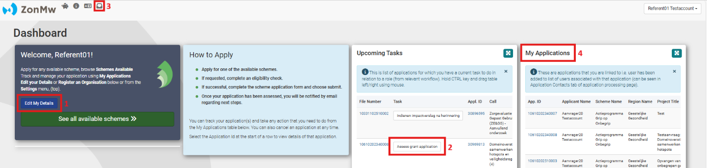
Figure 4: Inbox.

3 Assessment of grant applications
When ZonMw has informed you by email that a task is ready for you to assess a grant application, you can log in to My ZonMw. Tasks will be available for you in your inbox in My ZonMw.
- To start the assessment, simply click on a task (2 in Figure 4) after which you will see the overview screen (Figure 5).
- Right-click on the PDF with the application (1 in Figure 5) and open the application in a new tab.
- Click on the button on the right, ‘Start referentbeoordeling’ or ‘Assessment form’, to open the assessment form (2 in Figure 5).

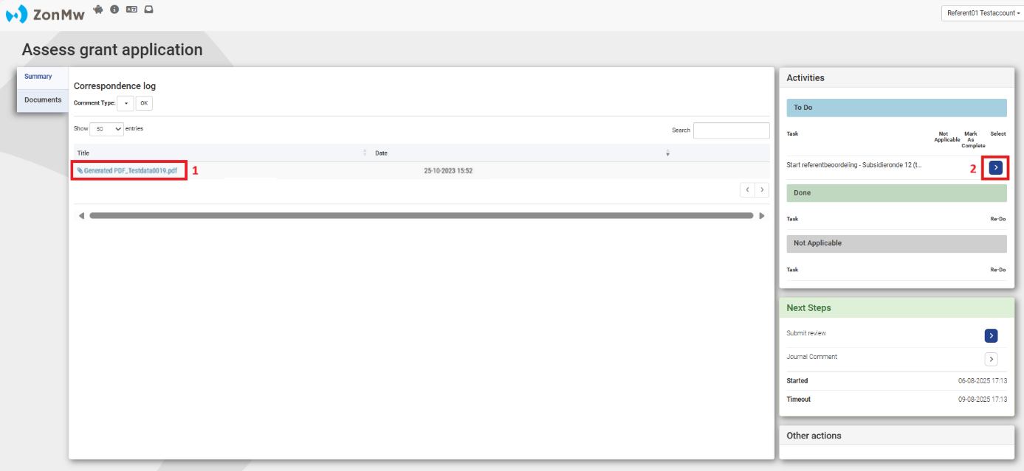
Figure 5: Assessing the application.

3.1 Assessment form: overview and completion
The assessment form consists of different sections:
- The sections in the assessment form are displayed as separate tabs. At the top of the screen you can see the title of the section you are working in (1 in Figure 6).
- Click on the title of a section (2 in Figure 6). This will take you to the questions within this section.
- The 'Print Form' and 'Generate new PDF' buttons (3 in Figure 6) are tools to share the assessment form (with or without entered text) offline with your colleagues in Word or PDF and to save it for your own administration. You will need to complete and submit all the information in the online application form.
- With the ‘Return to Index’ button (3 in Figure 6), you will see an overview of all the sections of the assessment form (Figure 7). The percentage bar under the section shows the extent to which the compulsory answers of the sections have been answered.
Please note: Make sure you always check all sections. Sections that do not contain compulsory questions are directly set to 100%. Clicking on the section title will take you to the questions in this section.

Completing the assessment form:
- By agreeing to assess the application, ZonMw will assume that you can be regarded as an independent expert in the relevant field without personal interests as referred to in the Code for dealing with personal interests of ZonMw. You agree by ticking the box “I can be regarded as an independent expert, without any conflict of interest” (4 in Figure 6).
- Click on ‘Section 2 Review form’ (2 in Figure 6) to find the various assessment questions where you can enter scores and explanations. Click on 'Select' (in Figure 8) to see the selection options.

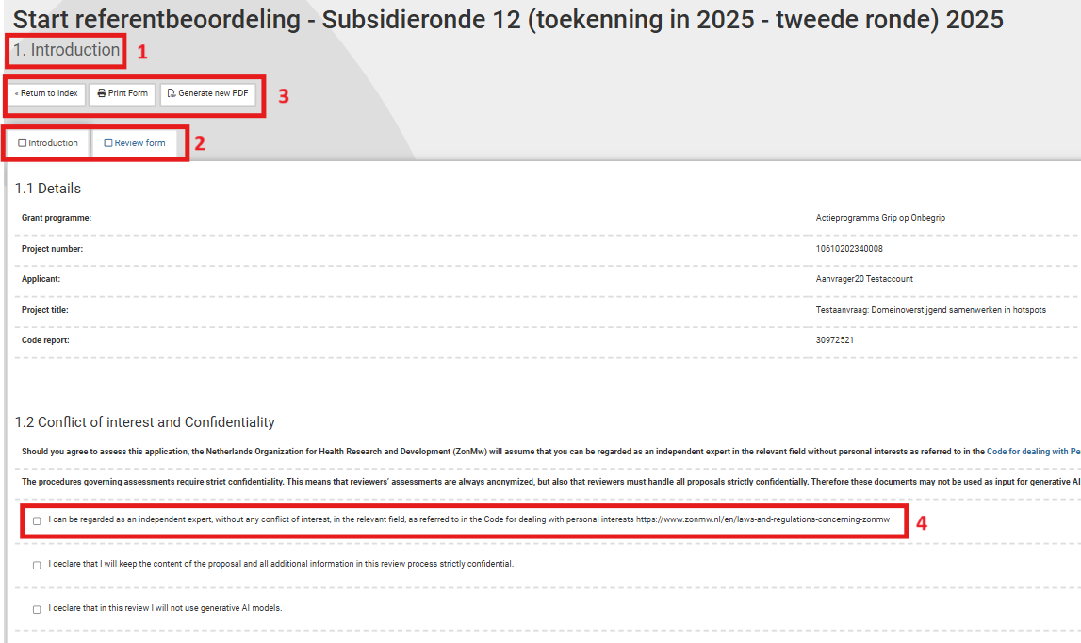
Figure 6: Opened section 1 of a review assessment form.

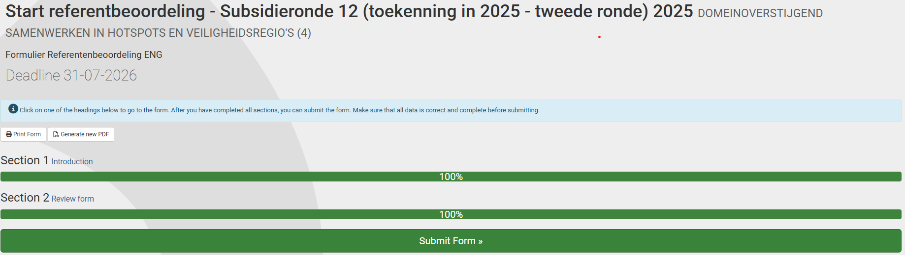
Figure 7: Overview of all sections of a referee evaluation form.

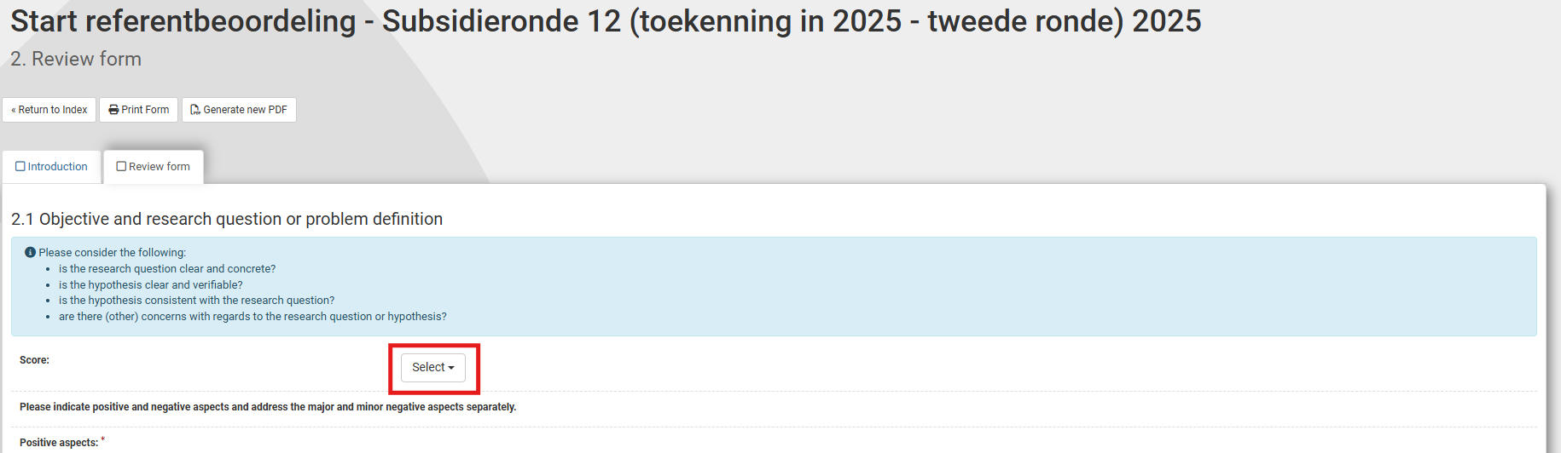Figure 8: Example of an assessment question with score and explanation.

3.2 Saving an assessment form
At the bottom of each section are 3 options that allow you to save an assessment form, move to the next section or submit the assessment form (Figure 12). The assessment form is also saved automatically every five minutes.
- ‘Save Draft’ lets you save information entered in the current section and stay in the current section of the form.
- ‘Save Draft & continue’ lets you save information entered in the current section and go to the next section of the form.
- ‘Save & exit’ lets you save information entered in the current section and submit the form.

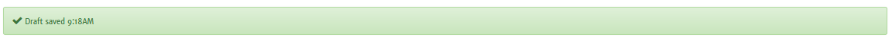
Figure 9: Form: save, continue and submit the entire form.

3.3 Submitting an assessment form
Once you have completed all sections, you can submit the form by clicking on the ‘Yes, submit entire form now!’ button (Figure 10). If compulsory questions have not yet been answered, the red block indicates which section and question still needs to be completed.
- Click on the section number in the red text to go directly to the question that still needs to be completed or click on ‘No, enter more details first’ to go back to the overview of all sections of the assessment form (Figure 7).

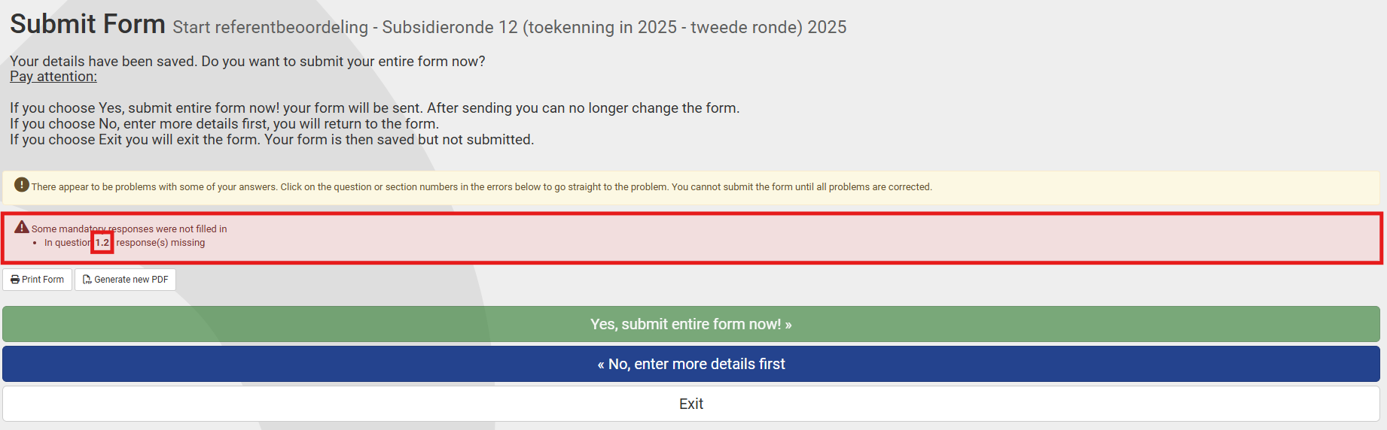
Figure 10: Notification of compulsory questions not yet answered.
- Click on if you do not want to submit the assessment form yet and would like to continue working on it later. The assessment will be saved in your inbox.
- Click on ‘Generate new PDF’ if you want to export the entire assessment form with entered text to PDF.

After submitting an assessment form, you will be directed to your inbox, where you will see the message ‘Your form was submitted successfully’. You will receive an automatic email as confirmation of receipt. The form will now be visible in ‘My ZonMw’ for the ZonMw staff involved in the relevant programme.
You can find your submitted assessment form in ‘My Applications’ (Figure 4).

- END OF THIS MANUAL -

