My ZonMw manual

For project leaders

August 10, 2025



Contents
1 What do I have to do over the course of my project? 3
2 Notification form 4
3 Entering products 7
3.1 Structure of a product form 8
3.2 Submitting products 10
4 Viewing documents 10
5 Progress report(s) 11
5.1 Structure of a progress report 12
5.2 Submitting a progress report 13
6 Final report 14
6.1 Structure of a final report 16
6.2 Submitting a final report 17

1 What do I have to do over the course of my project?
First of all: congratulations with your awarded grant application! To allow us to monitor your project’s progress, please complete a few more steps in My ZonMw.

At several points during the course of your project, you will need to upload documents to My ZonMw:
- One of the first documents you need to upload is the notification form.
- You can also upload ‘products’: project results and relevant publications. The task that allows you to upload these will become available at the same time as the task that allows you to upload the notification form.
- If you are required to submit a progress report, a task for this will automatically become available in My ZonMw 60 days before the deadline.
- A task that allows you to upload your final report will become available in My ZonMw 120 days before the specified end date of your project.
As soon as a task becomes available, you will receive an email to inform you of your submission deadline.

Notification form
Upload the notification form to My ZonMw within 4 weeks of the date of the award letter.

Reporting project results
Publications with respect to and the results of the project must be offered to ZonMw up to four years after the project has been completed. To add project results, please complete the appropriate form. You can find this form in the task in My ZonMw.

Progress report
To submit a progress report, please complete the appropriate form. You can find this form in the task in My ZonMw.

Final report
To submit a final report, please complete the appropriate form. You can find this form in the task in My ZonMw.

2 Notification form
If you are the applicant of the project the task ‘Prepare notification form’ (Dutch: Meldingsformulier invullen) will be added to your My ZonMw inbox (Figure 1).

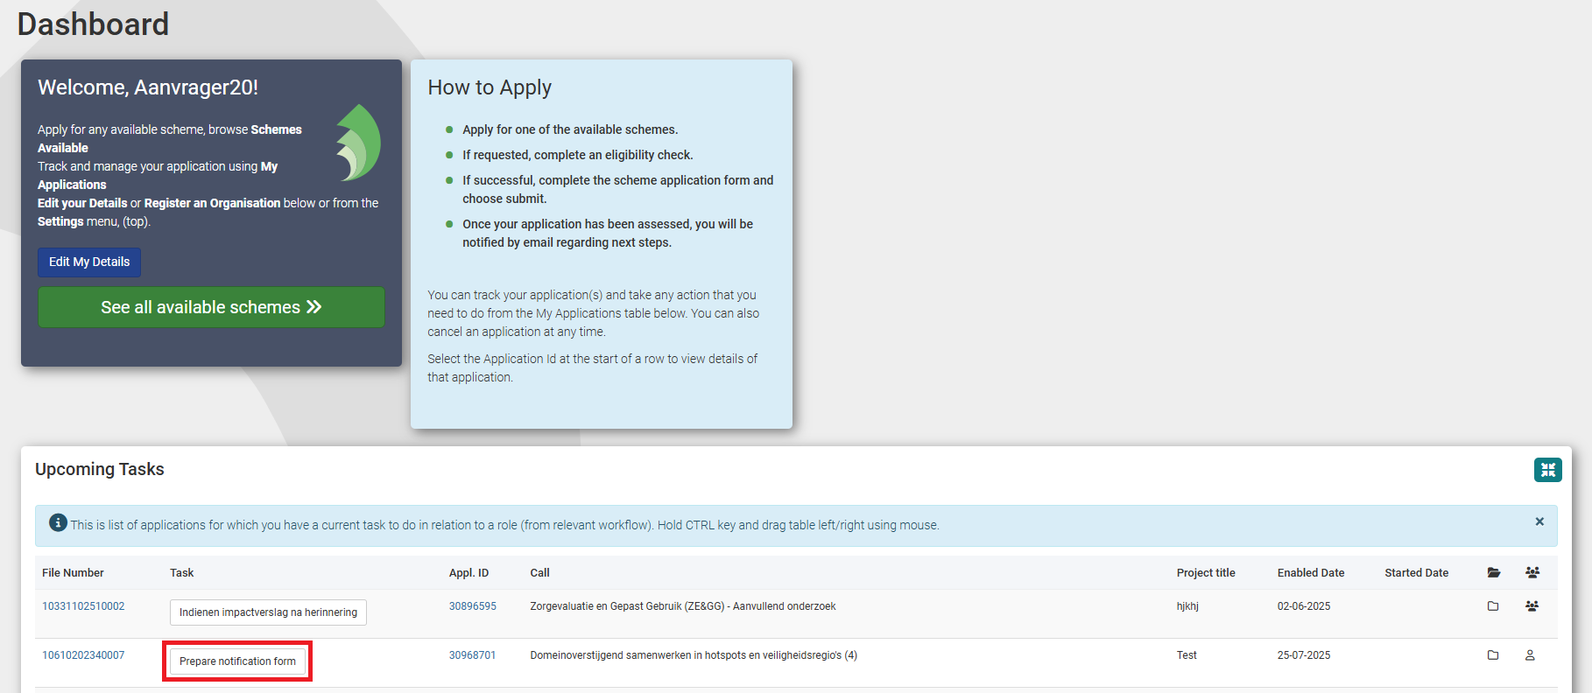
Figure 1: Inbox with tasks.
- Click on the task ‘Prepare notification form’ to open the task
- The notification form will open (figure 2). Please complete all the fields:
  - 1.2
    - Startdatum (Start date)
    - Looptijd (in maanden) (Planned duration (in months))
    - Einddatum (End date)
  - 1.3
    - Ten name van (Name on account)
    - Te (Town/city)
    - Bij betaling te vermelden kenmerk (Payment reference)
  - 1.4
    - Naam Instelling/Afdeling (Name Institution/Department)
    - E-mailadres t.b.v. ZonMw betaalspecificaties (Email address for ZonMw payment specifications)
    - Adres of Postbus (Address or PO Box)
    - Postcode (Postal code)
    - Plaats (Town/City)
  - 1.5
    - BTW nummer (VAT number)
    - KvK nummer (Chamber of Commerce number)
  - 1.6 please declare whether a positive METC/CCMO assessment or CCD/WBO project license is required. The options are:
    - A positive METC/CCMO assessment or CCD/WBO project license is not required (Dutch: Er is geen positief oordeel van METC/CCMO of een (project)vergunning van CCD/WBO vereist);
    - A positive METC/CCMO assessment or CCD/WBO project license is required (Dutch: Er is een positief oordeel van METC/CCMO of een (project)vergunning van CCD/WBO vereist);
    - A positive METC/CCMO assessment or CCD/WBO project license is required during the course of the project (Dutch: Tijdens de looptijd van het project is een positief oordeel van METC/CCMO of een (project)vergunning van CCD/WBO vereist);
  - 1.7 please indicate (if applicable) with who you will collaborate in drafting your datamanagementplan.
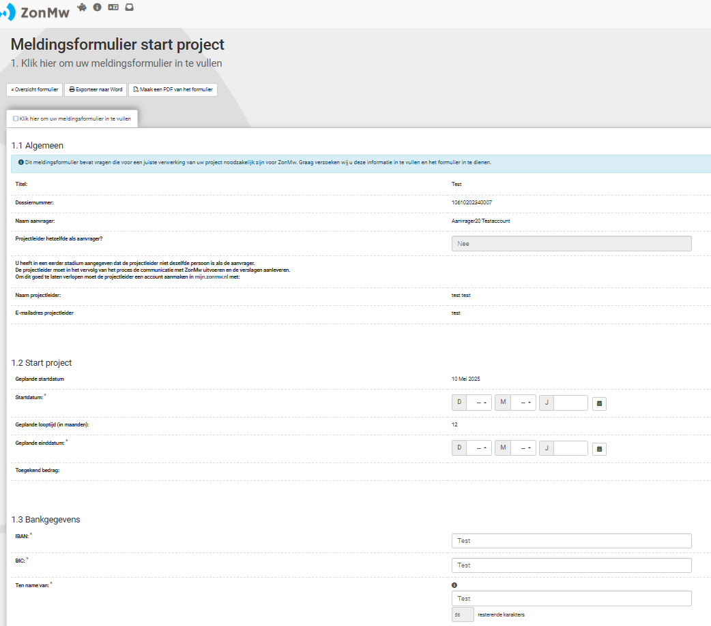
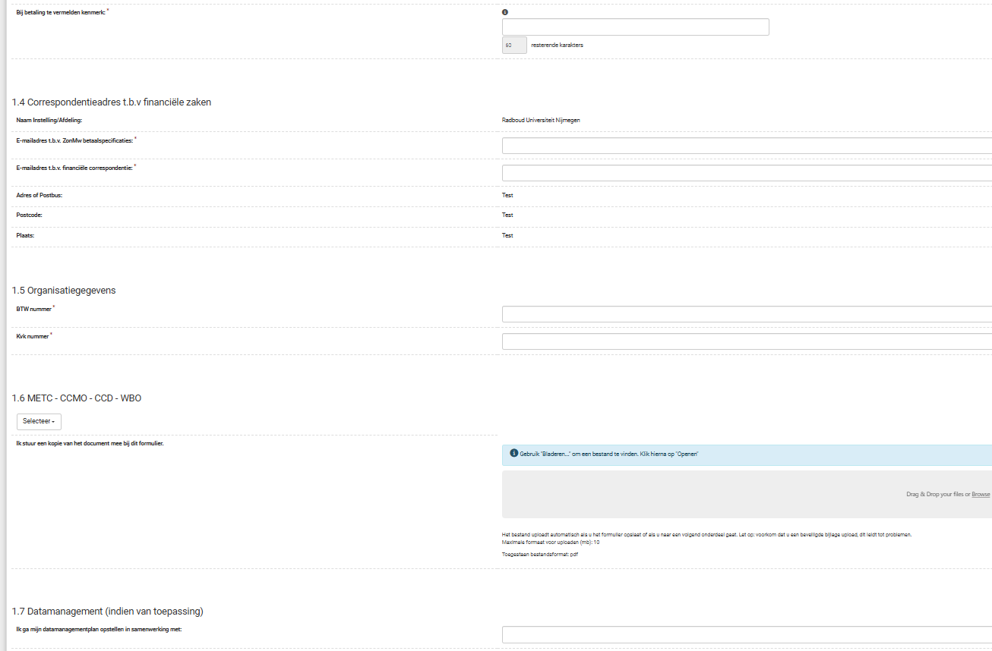
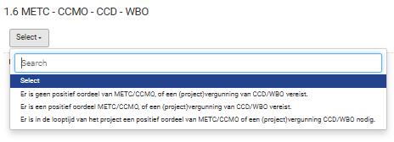
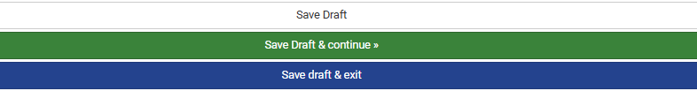
Figure 2: Notification form start project.
Once you have completed all sections, you can submit the form by clicking on ‘Save Draft & continue’ button (figure 2) and then on ‘Yes, submit entire form now!’ button (Figure 3). If compulsory questions have not yet been answered, the red block indicates which section and question still needs to be completed.
- Click on the section number in the red text to go directly to the question that still needs to be completed.
- Click on if you do not want to submit the notification form yet and would like to continue working on it later. The notification form will be saved in your inbox.
- Click on ‘Generate new PDF’ if you want to export the entire notification form with entered text to PDF. Please note: uploaded attachments are not visible in this PDF.

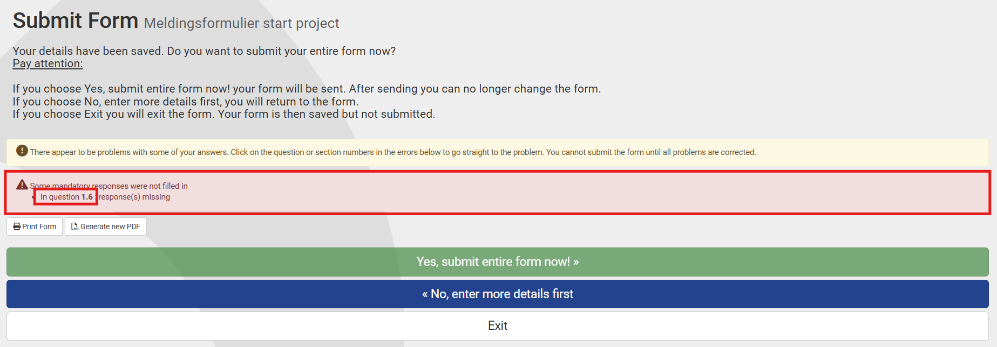
Figure 3: Submitting the notifcation form.
After submitting the notification form, you will be directed to your inbox, where you will see the message ‘Your form was submitted successfully’. You will receive an automatic email as confirmation of receipt. The form will now be visible in ‘My ZonMw’ for the ZonMw staff involved in the relevant programme.

3 Entering products
If you are the project leader, you can share your project results during and up to a period of 4 years after completion of the project. This not only concerns publications, but also for example educational products, data sets, practical or commercial applications (Figure 8).

You can submit results by logging into My ZonMw and clicking on ‘My Applications’ (Figure 4). Click on the right blue button ‘expand to full sized panel’.

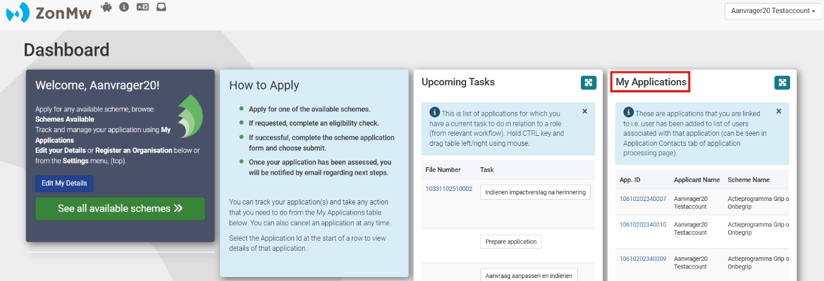
Figure 4: Inbox.
Here you will see your awarded grant application, click on the file number that you need (Figure 5).

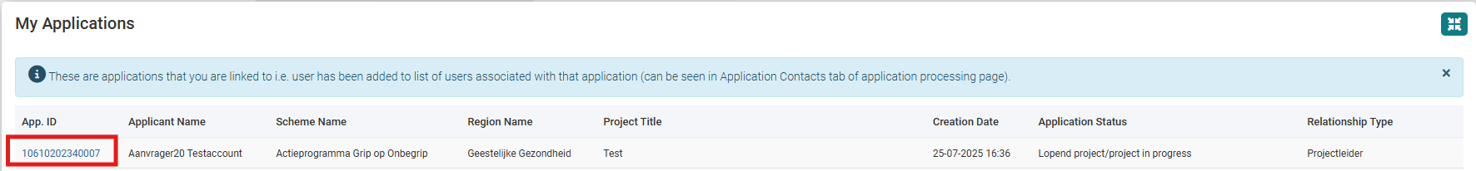
Figure 5: App ID to upload products.
Click on the button 'Enter product' (Figure 6.1). This will take you to the form (Figure 7).

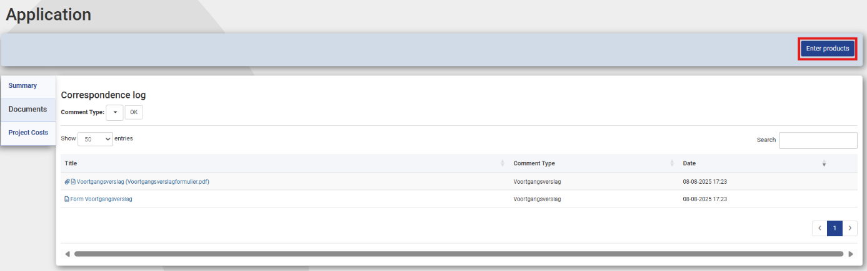
Figure 6.1: Enter products.
If you are not yet finished with your task, you can find it in ‘Upcoming Tasks’ (Figure 6.2).
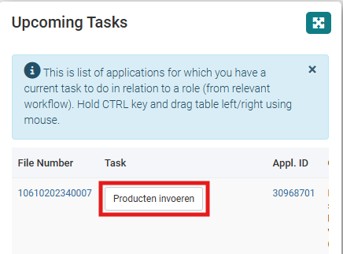
Figure 6.2: Enter products (Producten invoeren).

3.1 Structure of a product form
Select the tab you need (figure 7). Once you select a product type (1 in figure 8), follow-up questions specific to that product type will open.
After you have completed all fields, you have the choice to enter a next product using the 'Another Product' button (2 in Figure 8). If you do not want to add any more products, click on the 'Save Draft & continue' button.
Please note: You can add a maximum of 10 products in the same form. Would you like to submit more products? After submitting the form, please click on the task ‘Upload products (Dutch: Producten invoeren)’ again to open a new product form.
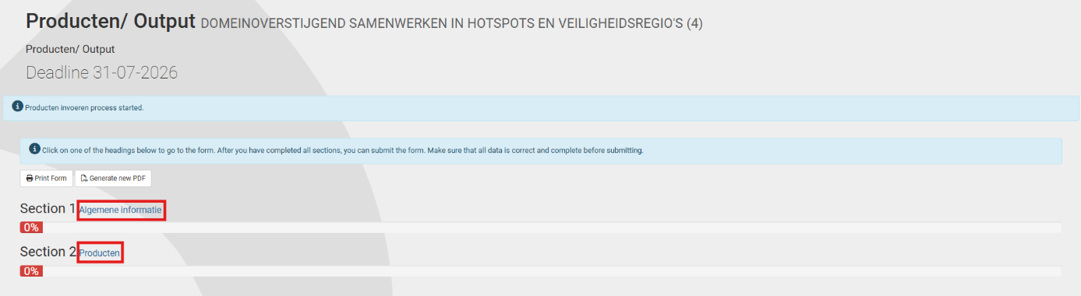
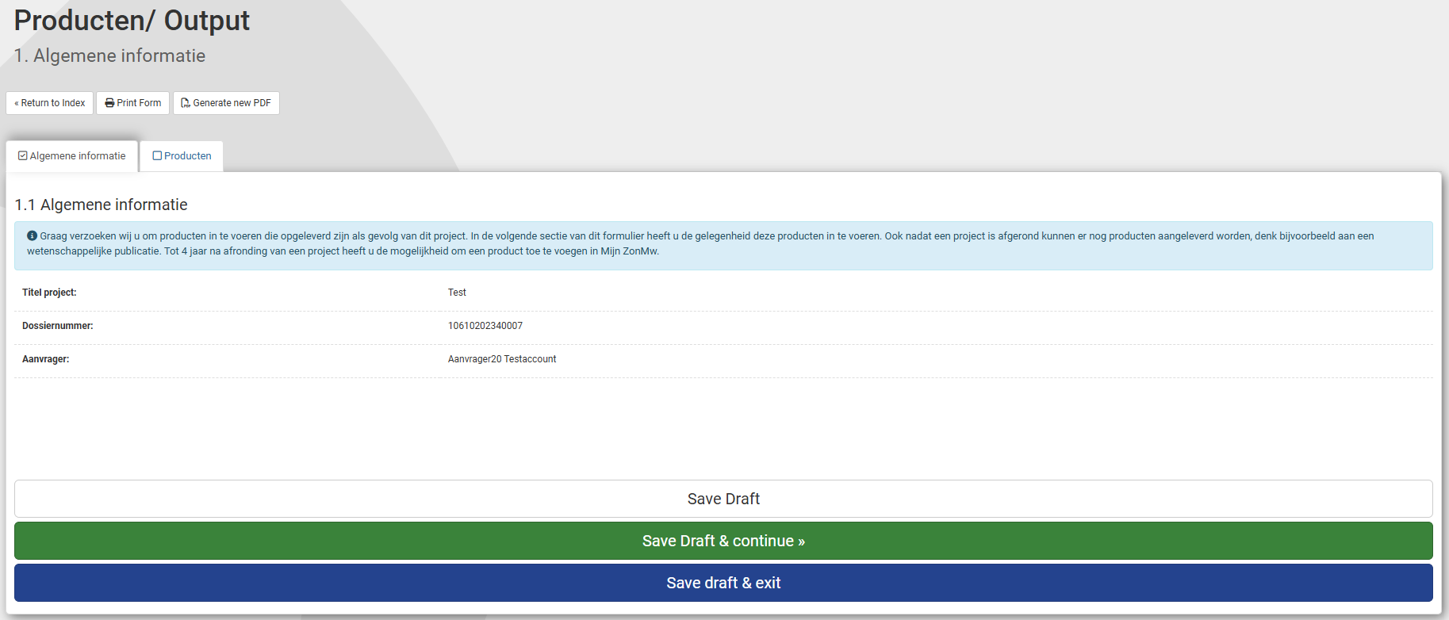
Figure 7: The product form (1).
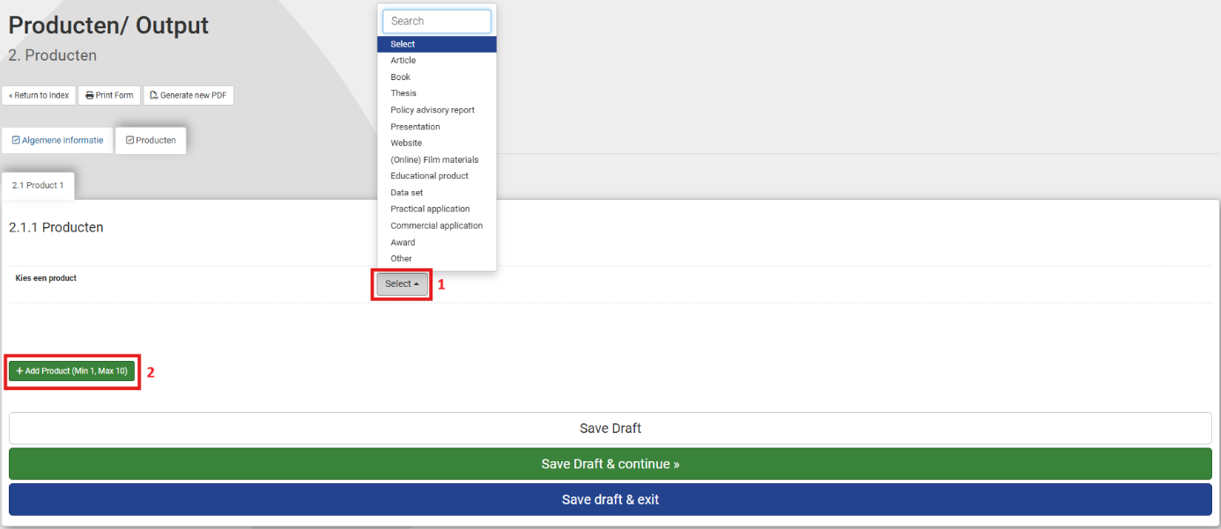
Figure 8: The product form (2).

3.2 Submitting products
Once you have completed all sections, you can submit the form by clicking on the ‘Yes, submit entire form now!’ button (Figure 9). If compulsory questions have not yet been answered, the red block indicates which section and question still needs to be completed.
- Click on the section number in the red text to go directly to the question that still needs to be completed.
- Click on if you do not want to submit the notification form yet and would like to continue working on it later. The notification form will be saved in your inbox.
- Click on ‘Generate new PDF’ if you want to export the entire notification form with entered text to PDF.

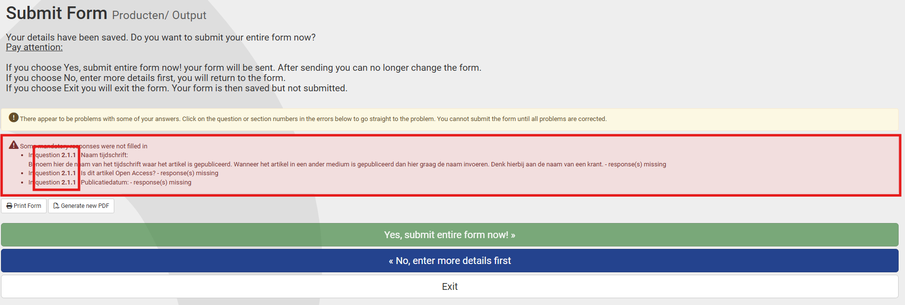
Figure 9: Submitting the product form.
After submitting the product form, you will be directed to your inbox, where you will see the message ‘Your form was submitted successfully’. You will receive an automatic email as confirmation of receipt. The form will now be visible in ‘My ZonMw’ for the ZonMw staff involved in the relevant programme. Your product will also be visible on the ZonMw website the next day.

Please note: if your product is confidential and may therefore not be shown on the website (yet), for example due to patents/competitors, you should not submit the product via My ZonMw. Please submit the product by sending an email to your program contact. As soon as the product is allowed to be shown on the website, please submit the product via My ZonMw.

The ‘Upload products’ button will remain available under the ‘Applications I Am Linked To’ for up to 4 years after the project has been completed.

4 Viewing documents
You can view documents that you have submitted by logging in to My ZonMw. Click on the right blue button ‘expand to full sized panel’ besides ‘My Applications’ (Figure 4) for an overview of all current / completed applications. Click on the desired file number and then click on the ‘Documents’ tab (figure 10). Here you will see an overview of all the documents you have submitted.

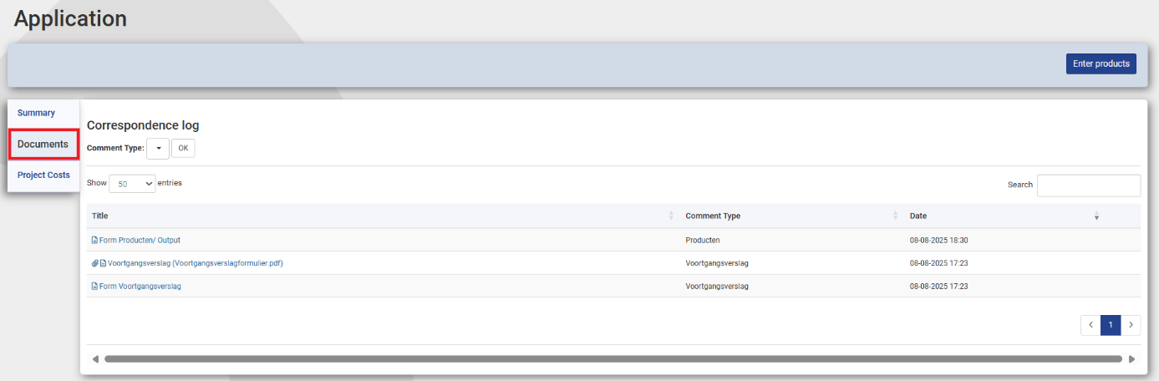
Figure 10: Overview of the documents.

5 Progress report(s)
If you are the project leader of the project, we may ask you to share a progress report with us during the course of your project. This allows ZonMw to monitor your project. You will receive a request by email 60 days before the submission deadline of the progress report. The task to submit your progress report will be visible in My ZonMw (Figure 11). You will receive the conditions and form associated with the progress report by email.

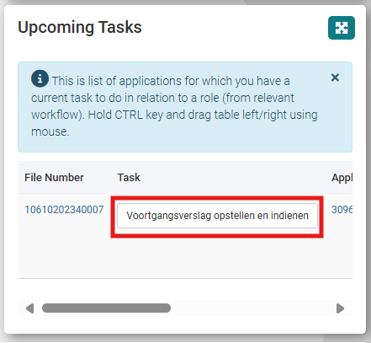
Figure 11: Drafting and submitting a progress report task.
Click on the task prepare and submit progress report (Dutch: Voortgangsverslag opstellen en indienen). This will take you to the form (Figure 12).

5.1 Structure of a progress report
The progress report form consists of different sections:
- The sections in the progress report are displayed as separate tabs. At the top of the screen you can see the title of the section you are working in (1 in Figure 12).
- Click on the title of a section (2 in Figure 12). This will take you to the questions within this section.
- The 'Print Form' and 'Generate new PDF' buttons (3 in Figure 12) are tools to share the progress report (with or without entered text) offline with your colleagues in Word or PDF and to save it for your own administration. You will need to complete and submit all the information in the online progress report.
- With the ‘Return to Index’ button (3 in Figure 12), you will see an overview of all the sections of the progress report (Figure 13). The percentage bar under the section shows the extent to which the compulsory answers of the sections have been answered.
Please note: Make sure you always check all sections. Clicking on the section title will take you to the questions in this section.

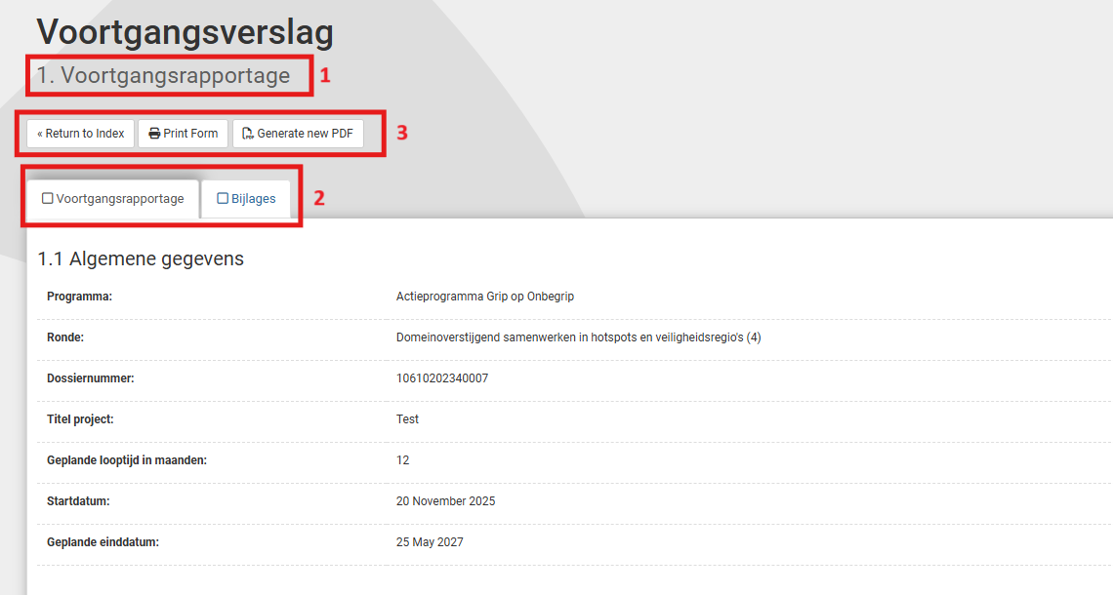
Figure 12: Opened section 1 of a progress report.
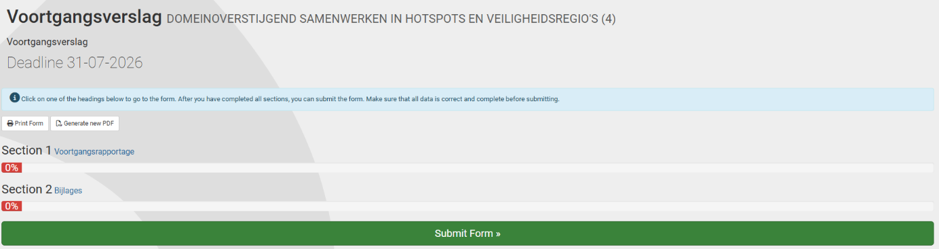
Figure 13: Overview of all sections of a progress report.
Please complete all fields:
- 1.2
  - Startdatum rapportageperiode (Start date reporting period)
  - Einddatum rapportageperiode (End date reporting period)
  - Samenvatting en tussentijdse resultaten Nederlands (Comprehensive summary and interim results in Dutch)
  - Samenvatting en tussentijdse resultaten Engels (Comprehensive summary and interim results in English)
- 1.3
  - Publiekssamenvatting Nederlands (Public summary in Dutch)
  - Publiekssamenvatting Engels (Public summary in English)
- 2.1
  - Voortgangsverslagformulier (Progress report form)

5.2 Submitting a progress report
Once you have completed all sections, you can submit the form by clicking on the ‘Yes, submit entire form now!’ button (figure 14). If compulsory questions have not yet been answered, the red block indicates which section and question still needs to be completed.
- Click on the section number in the red text to go directly to the question that still needs to be completed or click on ‘No, enter more details first’ to go back to the overview of all sections of the progress report form (figure 13).

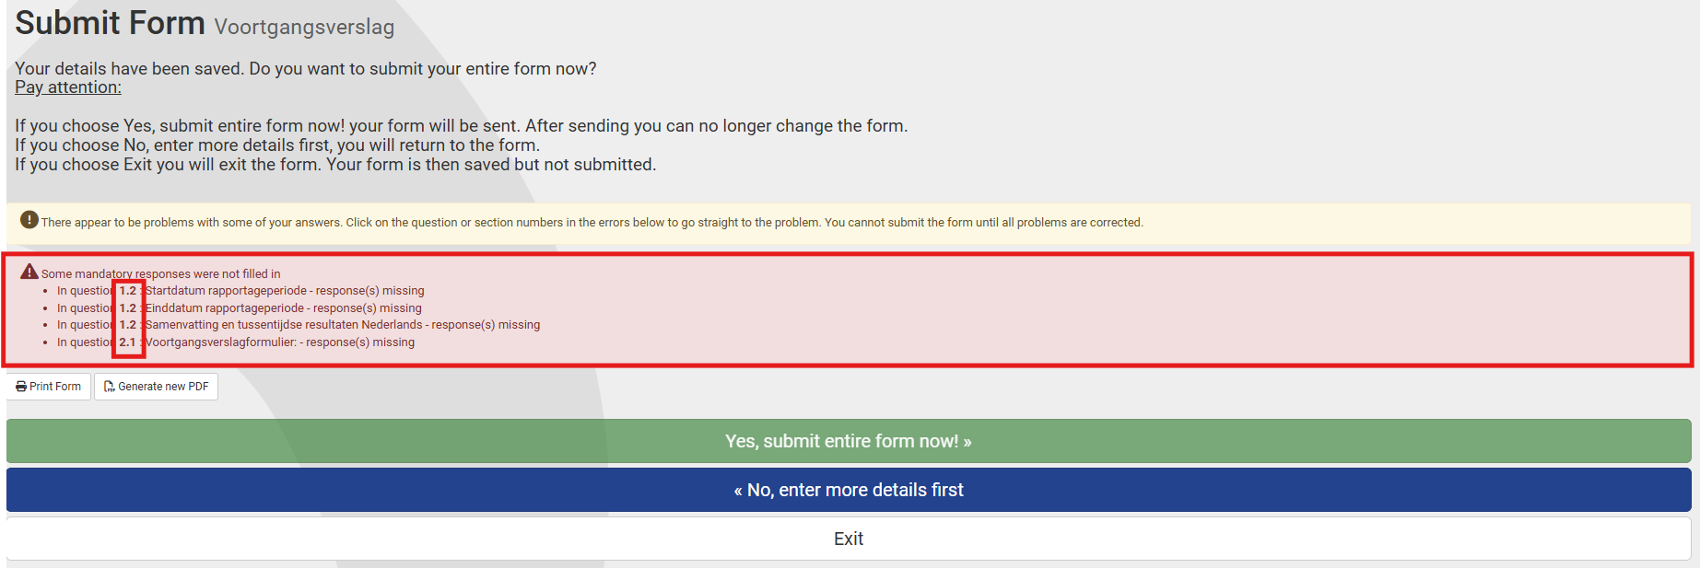
Figure 14: Submitting a progress report.
- Click on if you do not want to submit the progress report yet and would like to continue working on it later. The progress report will be saved in your inbox.
- Click on ‘Generate new PDF’ if you want to export the progress report with entered text to PDF. Please note: uploaded attachments are not visible in this PDF.

After submitting the progress report, you will be directed to your inbox, where you will see the message ‘Your form was submitted successfully’. You will receive an automatic email as confirmation of receipt. The form will now be visible in ‘My ZonMw’ for the ZonMw staff involved in the relevant programme. You can find your submitted progress reports in the Documents tab (Figure 10).

6 Final report
If you are the project leader, you must share a final report and financial statement with us after completion of the project. This allows ZonMw to assess your project. You will receive a request by email 120 days before the submission deadline of the final report. The task to submit your progress report will be visible in My ZonMw (figure 15). You will receive the conditions and form associated with the progress report by email.

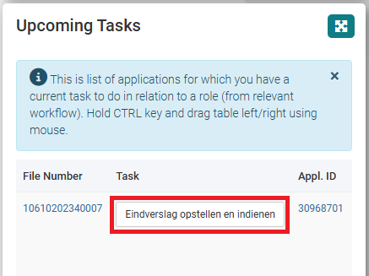
Figure 15: Drafting and submitting a final report task.
Click on the task prepare and submit final report (Dutch: Eindverslag opstellen en indienen). This will take you to the form (figure 16).

6.1 Structure of a final report
The final report form consists of different sections:
- The sections in the final report are displayed as separate tabs. At the top of the screen you can see the title of the section you are working in (1 in Figure 16).
- Click on the title of a section (2 in Figure 16). This will take you to the questions within this section.
- The 'Print Form' and 'Generate new PDF' buttons (3 in figure 16) are tools to share the final report (with or without entered text) offline with your colleagues in Word or PDF and to save it for your own administration. You will need to complete and submit all the information in the online final report.
- With the ‘Return to Index’ button (3 in figure 16), you will see an overview of all the sections of the final report (figure 17). The percentage bar under the section shows the extent to which the compulsory answers of the sections have been answered.
Please note: Make sure you always check all sections. Clicking on the section title will take you to the questions in this section.

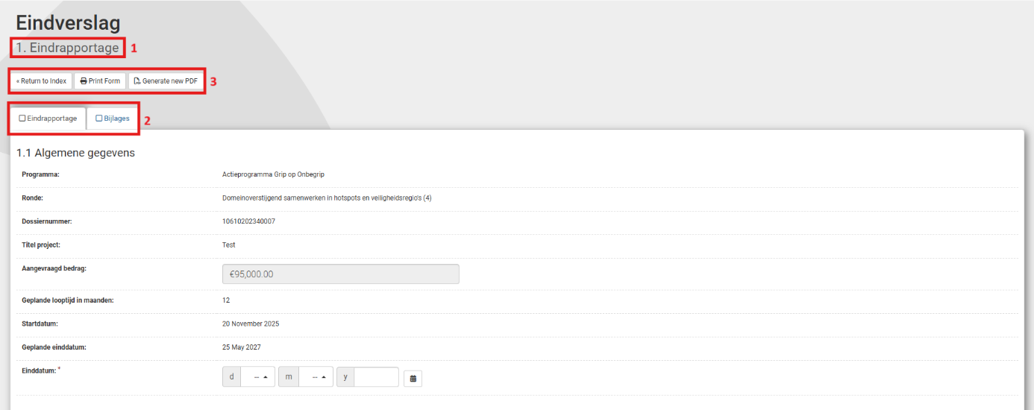
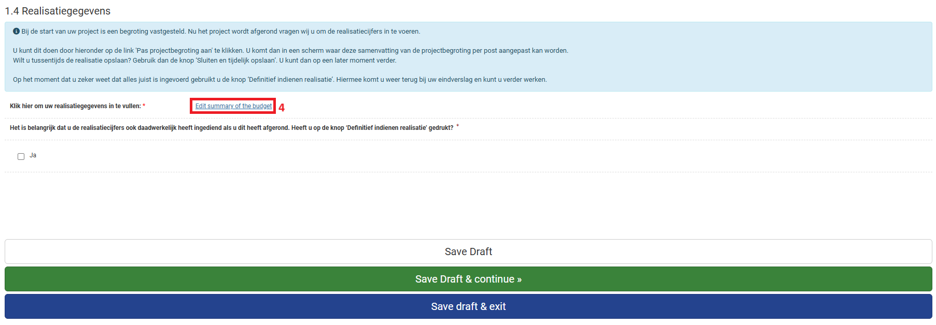
Figure 16: Opened section 1 of a final report.

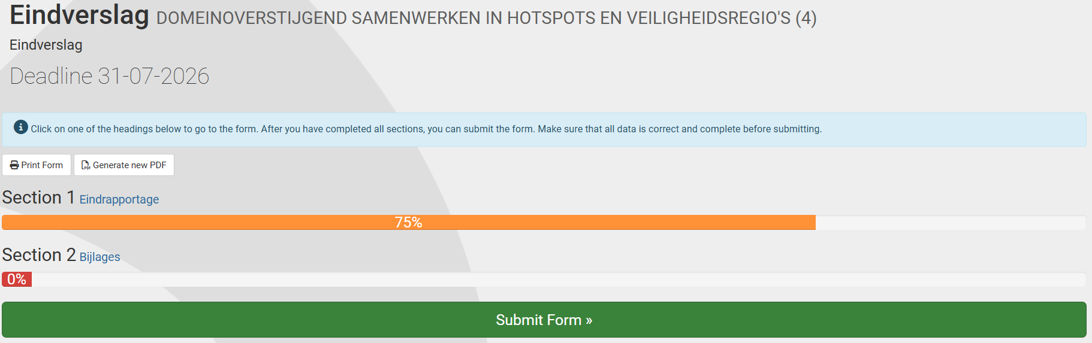
Figure 17: Overview of all sections of a final report.
Please complete all fields:
- 1.1
  - Einddatum (End date)
- 1.2
  - Samenvatting Nederlands (Comprehensive summary in Dutch)
  - Samenvatting Engels (Comprehensive summary in English)
- 1.3
  - Publiekssamenvatting Nederlands (Public summary in Dutch)
  - Publiekssamenvatting Engels (Public summary in English)
- 2.1
  - Eindverslagformulier (General Final report form)
  - Financiële eindafrekening (Financial report)
  - Verklaring akkoord eindrapportage (Statement of agreement final report and financial statement, which can be downloaded here)

As part of the final report, you will usually be required to fill in the realisation data in section 1.4. To do this, click on the ‘Edit Project Costs’ link (4 in Figure 16). Please note: This opens the same budget module you used to submit your budget during the application process (figure 18). You can adjust each budget item to reflect realisation. Once you are sure that you have completed every tab correctly, click the ‘Submit final budget’ (Dutch: Definitief indienen realistatie) button. This will take you back to your final report.

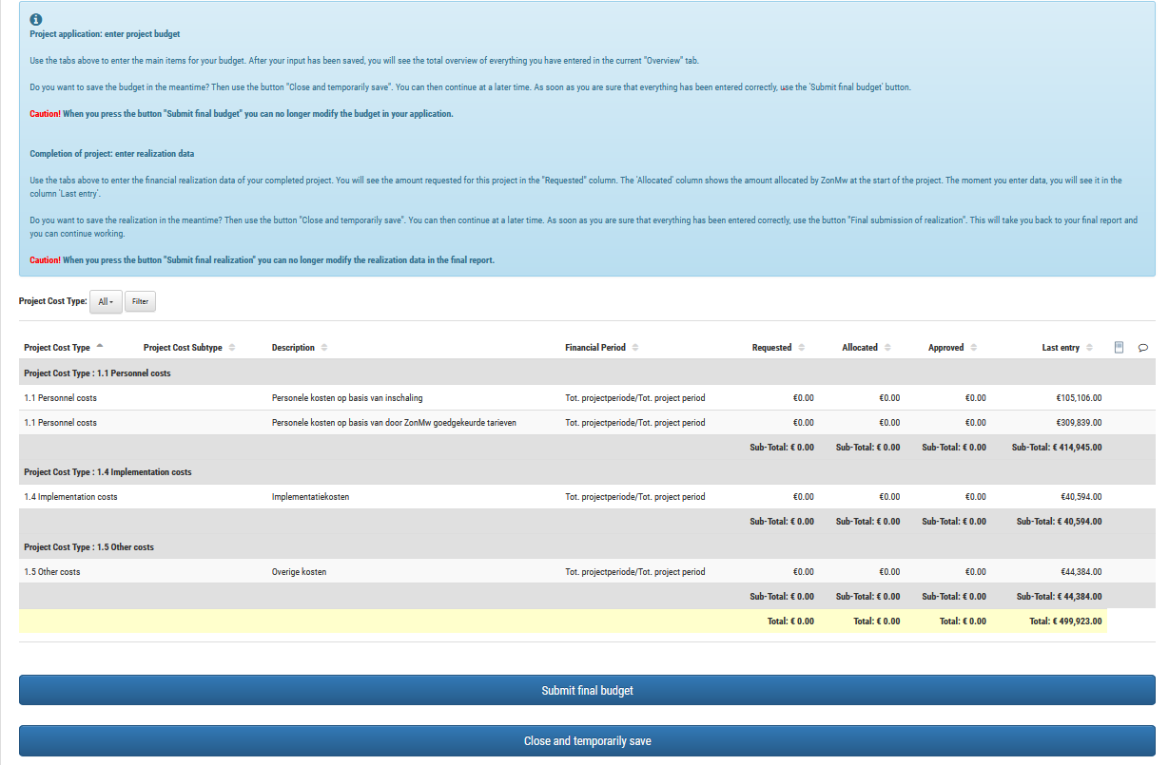
Figure 18: Submitting realisation data in the budget module.

6.2 Submitting a final report
Once you have completed all sections, you can submit the form by clicking on the ‘Yes, submit entire form now!’ button (figure 19). If compulsory questions have not yet been answered, the red block indicates which section and question still needs to be completed.
- Click on the section number in the red text to go directly to the question that still needs to be completed or click on ‘No, enter more details first’ to go back to the overview of all sections of the final report form (figure 17).

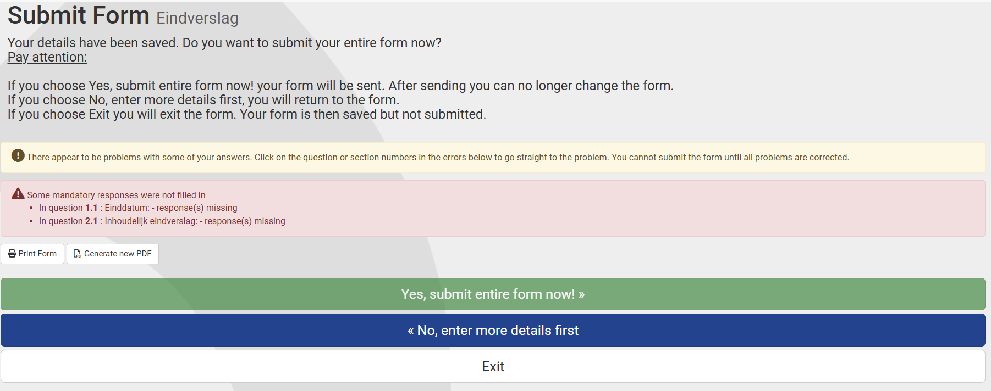
Figure 19: Submitting a final report.
- Click on if you do not want to submit the final report yet and would like to continue working on it later. The final report will be saved in your inbox.
- Click on ‘Generate new PDF’ if you want to export the final report with entered text to PDF. Please note: uploaded attachments are not visible in this PDF.

After submitting the final report, you will be directed to your inbox, where you will see the message ‘Your form was submitted successfully’. You will receive an automatic email as confirmation of receipt. The form will now be visible in ‘My ZonMw’ for the ZonMw staff involved in the relevant programme. You can find your submitted final report in the Documents tab (figure 10).

- END OF THIS MANUAL -

