My ZonMw manual

For applicants

August 8 2025



Credits

ZonMw encourages health research and care innovation
ZonMw funds health research and encourages use of this knowledge to help improve health and
health care.

ZonMw’s main contractors are the Dutch Ministry of Health, Welfare and Sport (VWS) and the Dutch
Research Council (NWO).

Should you have any questions, please do not hesitate to contact the secretariat at the email address
or phone number provided below.

ZonMw
Laan van Nieuw Oost-Indië 334
Postbus 93245
2509 AE Den Haag
Phone: +31 (0)70 349 51 11
www.zonmw.nl
info@zonmw.nl

Social media
www.facebook.com/zonmwNL
www.twitter.com/zonmw
www.linkedin.com/company/zonmw
www.youtube.com/ZonMwTV

Contents

Introduction 4
1 Starting in My ZonMw 5
1.1 Registering as a new user 5
1.2 Logging in as an existing user 6
1.3 Resetting your password 6
1.4 Select language 6
2 Submitting a grant application 6
2.1 Structure of the application form 7
2.2 Saving your data 8
2.3 Inbox 8
2.4 Submitting the application form 9
3 Submitting your rebuttal 10

Introduction
This manual explains how the grant application process works in My ZonMw.

Section 1 explains how to get started in My ZonMw. This section explains how to register as a new
user, how to log in and how to change your user settings.

Section 2 explains how you can apply for a grant. This section describes how to open, complete, save
and submit an application form.

Some grant calls are subject to referee assessments. Section 3 explains how to submit a rebuttal in
response to the referee assessments. In this phase, you will receive an email from ZonMw to inform
you about the conditions of the rebuttal.

Please note: Each programme has its own application and assessment procedure. This programme-specific procedure is communicated in the grant call. Therefore, the steps in the standard procedure may vary depending on the programme you are applying to.

Important! Make sure the documents you upload are not secured. Budgets or other files signed (for example, with ValidSign) often automatically have security applied. Make sure you remove this before uploading the file, otherwise the system will not be able to process it properly. You can check if your PDF has security applied by opening it in Adobe Acrobat, right-clicking, going to document properties, and then selecting the Security tab. There you can see if and how your file is secured. You can also open the PDF in a browser; if your file is secured, this will be displayed in a bar at the top

1 Starting in My ZonMw
You will find the open grant calls on the ZonMw website.

After reading the grant call, you can click on this button to apply for a grant
This takes you to the login page of My ZonMw.

1.1 Registering as a new user
If you have not logged into My ZonMw before, you must register first (Figure 1 & 2).
- To do so, click on the button to register as a new user and create an account.
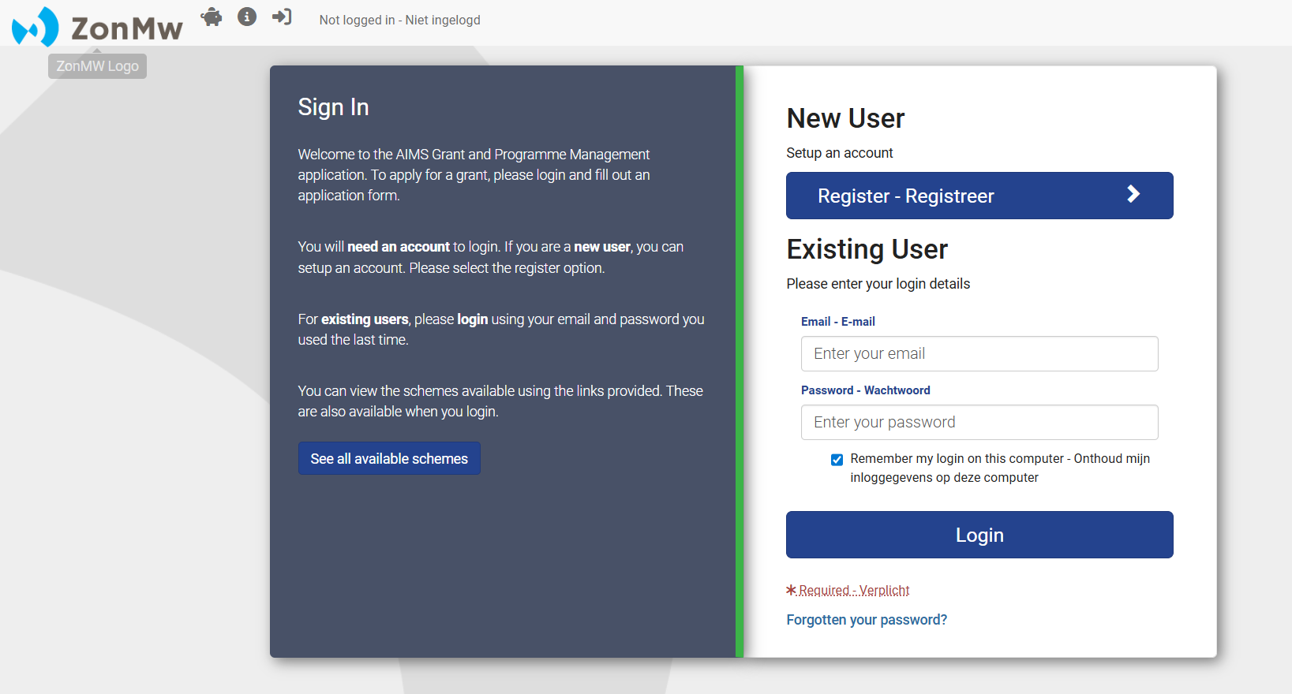
Figure 1: Registering with or logging in to My ZonMw.
- Please complete all required fields. You can recognise these throughout the application by the in front of them
- Then click on the button.
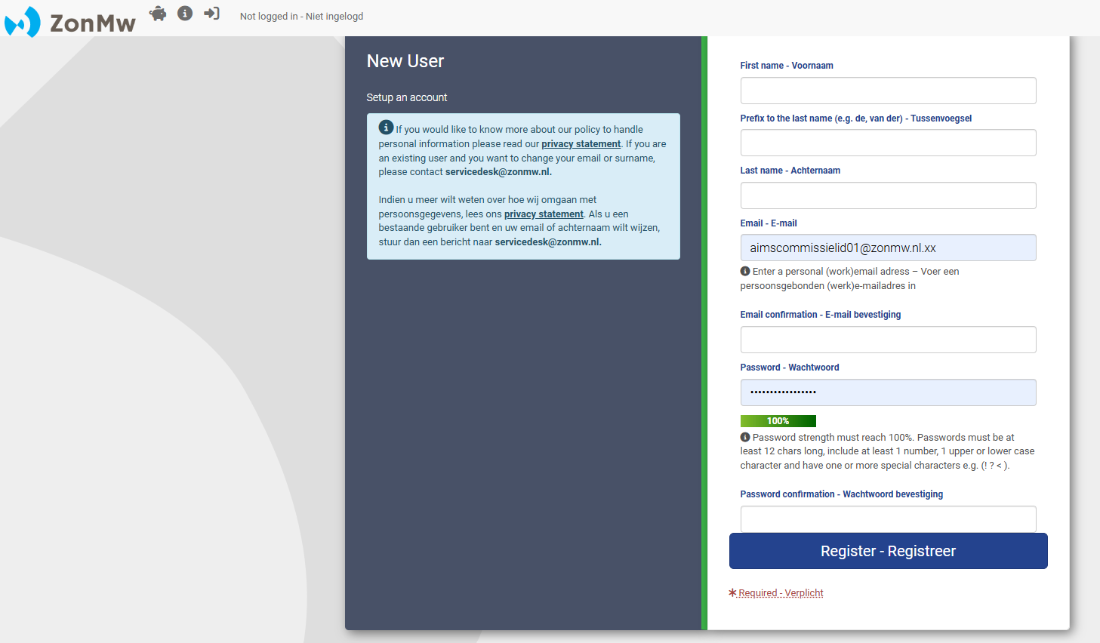

Figure 2: Registering as a new user.
Please bear in mind that in My ZonMw, only passwords of at least 12 characters are possible and
they must include 1 number, 1 upper of lower case character and 1 special character. You can use Norton Password Creator to create a password. Remember to save your password for later sessions in your browser or in a password manager.

1.2 Logging in as an existing user
If you have logged into My ZonMw before, you can log in with your email address and password
(Figure 1).
- Log in as an existing user by entering your email address and password and clicking on 
- If you have forgotten your password, click on ‘Forgotten your password?

Please note If you enter your password incorrectly five times in succession, your account
will be locked. In that case, you can send an email to servicedesk@zonmw.nl with the
request to unlock your My ZonMw account.

1.3 Resetting your password
If you have forgotten your password, you can reset your password (Figure 3):
- Enter your email address at ‘Email’.
- Then click on the button 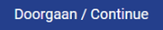.

You will receive an email with a link to create a new password.
Please note: if you do not receive an email, please check whether the email has ended up in your junk email / spam folder.

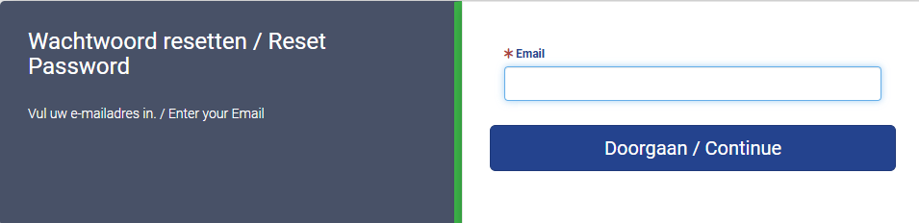
Figure 3: Resetting your password.

1.4 Select language
When you log in for the first time, My ZonMw is set to English. You can change the language by
clicking on at the top of the menu bar after you have logged in (Figure 4).

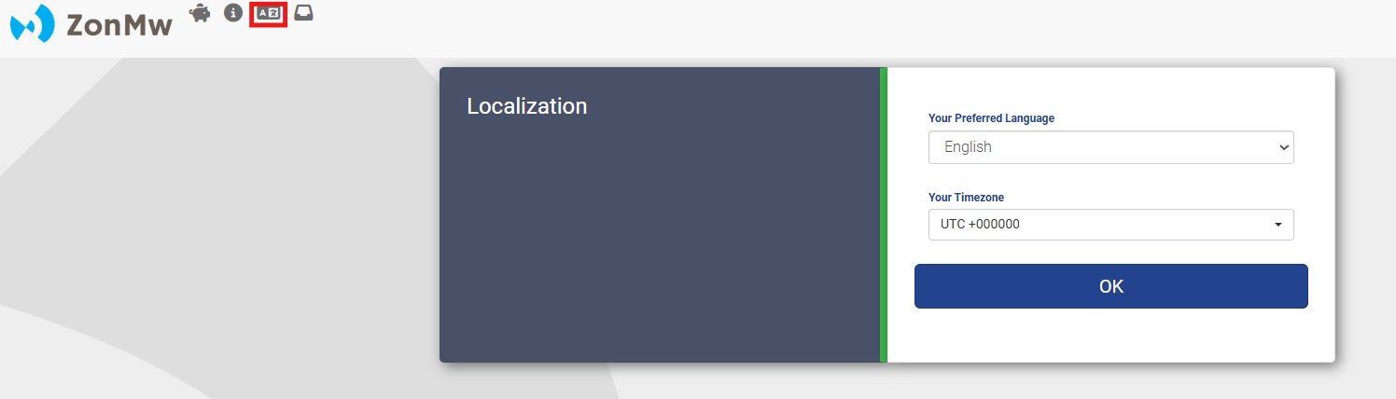
Figure 4: Selecting the language

2 Submitting a grant application
If you have clicked on the 'Apply for a subsidy' button via the open subsidy call on the ZonMw website and then logged in to My ZonMw, you will directly go to Section 1 of the application form (Figure 5).
If you log in directly to My ZonMw, you can view the calls open for proposal by clicking on at the top of the menu bar (Figure 6). By then clicking on the 'Apply now' button (Figure 6) you will enter Section 1 of the application form (Figure 5).
Once the application form opens, you can always find it in your inbox under 'Tasks' (Figure 9). This also applies if you have not yet entered any information in the application form.

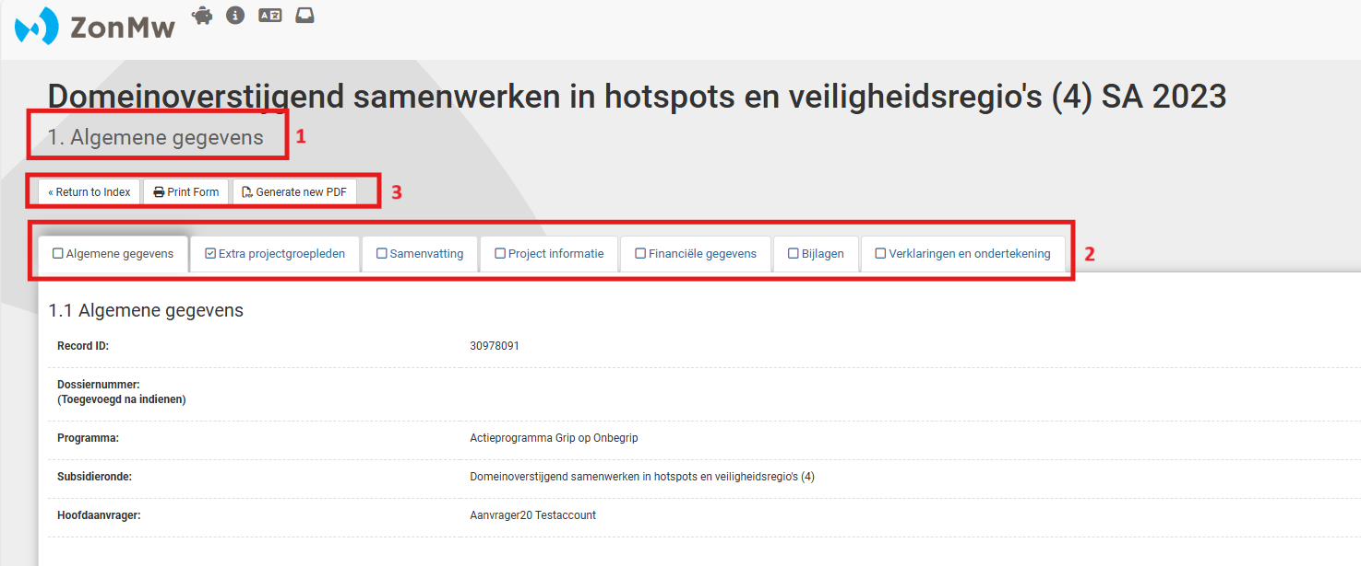
Figure 5: Opened section 1 of an application form.
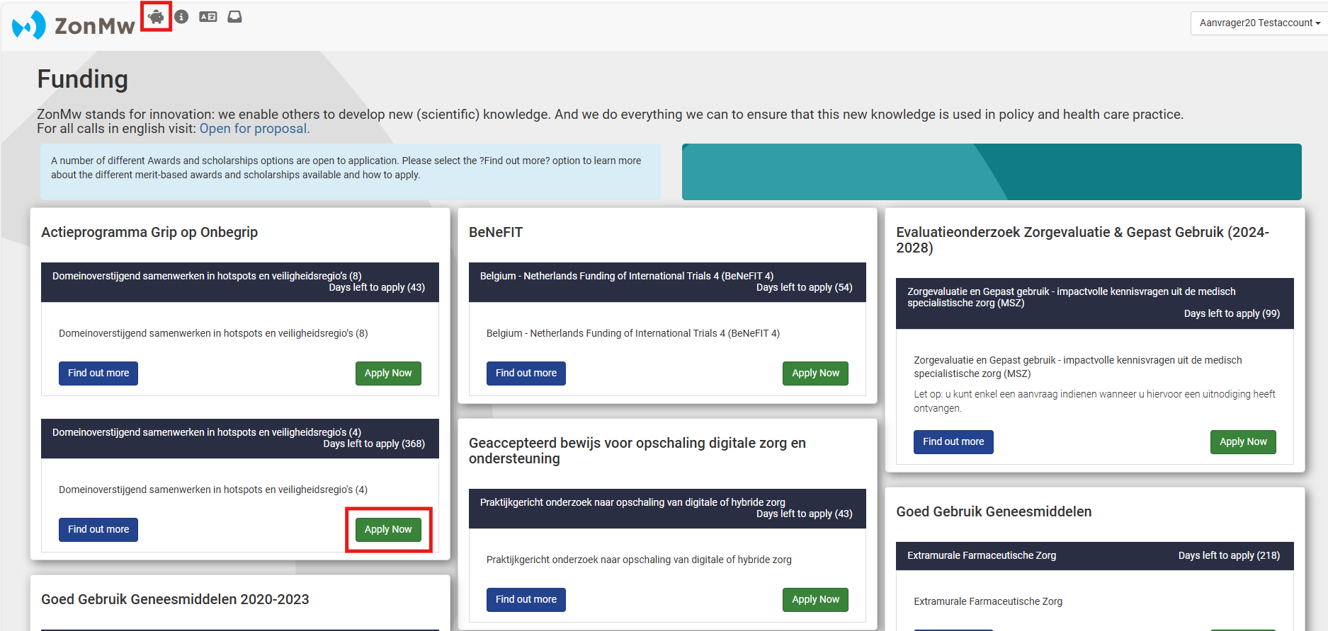
Figure 6: Calls open for proposal.

2.1 Structure of the application form
The application form consists of several sections:
- The sections in the application form are displayed as separate tabs. You can see the name of the section you are working in at the top of the screen (1 in Figure 5).
- Click on the title of a section (2 in Figure 5) to go to the questions in that section.
- The buttons 'Print Form' (this will open in Word) and 'Generate new PDF' buttons (3 in Figure 5) are tools to share the application form (with or without entered text) offline with your colleagues and save it for your own administration. You will ultimately need to complete and submit all information in the application form online.
- With the button ‘Return to Index’ (3 in Figure 5) you will be shown an overview of all sections that make up the application form (Figure 7). The percentage bar below the section shows whether you have answered all the compulsory questions of a section.
Please note: Make sure you always check all sections. Sections that do not contain compulsory questions, but that can be completed are directly set to 100% (such as Section 2 in Figure 7).

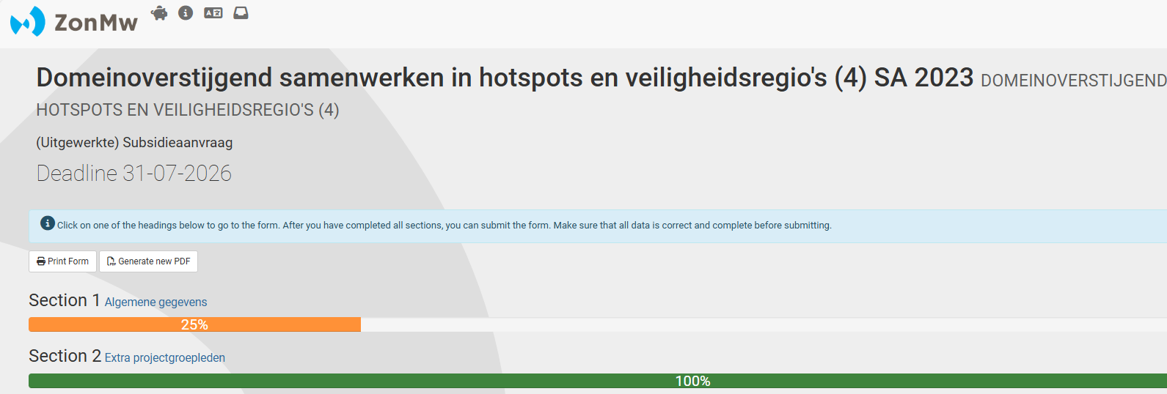
Figure 7: Overview of all sections of an application form.

2.2 Saving your data

You have options to save your application data at the bottom of each section (Figure 8). Your data are
saved automatically every five minutes (see green bar in Figure 8), but can also be saved manually.
After you have saved your data, you can continue with your application at a later time. The next time
you log in you will find your application in your inbox (Figure 9).

- Save draft: You can use the button  to save your application data at any time. You will remain in the current section of the application form.

- Save draft & continue: You can use the button to save your application data and go to the next section in the application form.

- Saving & submit form: You can use the button to save your application data and go to the next step, ‘Submit form’.

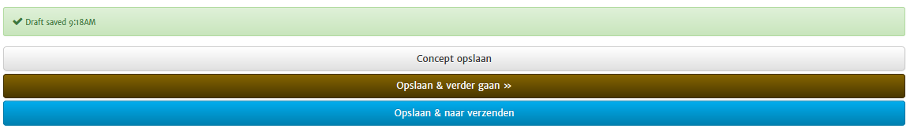
Figure 8: Saving the application data.

2.3 Inbox
If you are not logging in to My ZonMw via an open grant call or if you click on  in the menu bar at
the top of the page, you will be directed to your inbox (Figure 9). You will find all the activities you are
working on for a grant application in your inbox, where you will see the following parts:

- Tasks: A document number is available for each application. The task description shows which task you still need to complete for an application. This may be any of the following tasks ‘Submit an application’, ‘Submit a rebuttal’ or ‘Submit a progress report’.

- My Applications: Once you have completed the tasks associated with your application, it will appear in this section of your inbox.

- Edit My Details: Click on the button to modify your name and address details and to view your current applications.
Please note: you cannot change your middle name, last name and email address yourself. Send an email to servicedesk@zonmw.nl.

- Create New Application: Click on the button if you would like to submit a new grant application. You will be directed to a new screen where you can find all open grant calls.

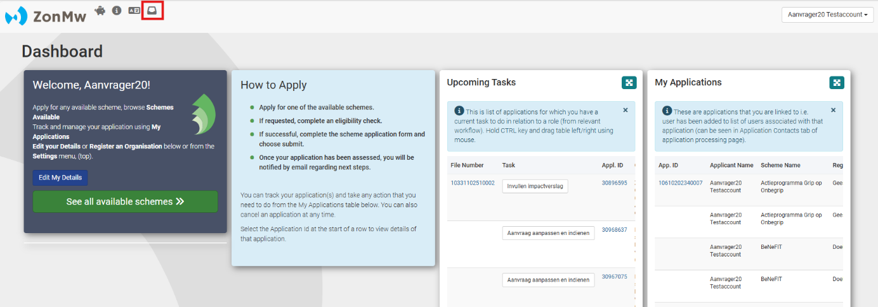
Figure 9: Inbox.

2.4 Submitting the application form
Once you have completed all the sections, you can submit the form by clicking on the ‘Yes, submit
entire form now!’ button (Figure 10). If the compulsory questions have not yet been answered, a red
block indicates which section and question still need to be completed.
- Click on the red text on the section number to go directly to the question to be answered or click on to go back to the section overview of the application form.

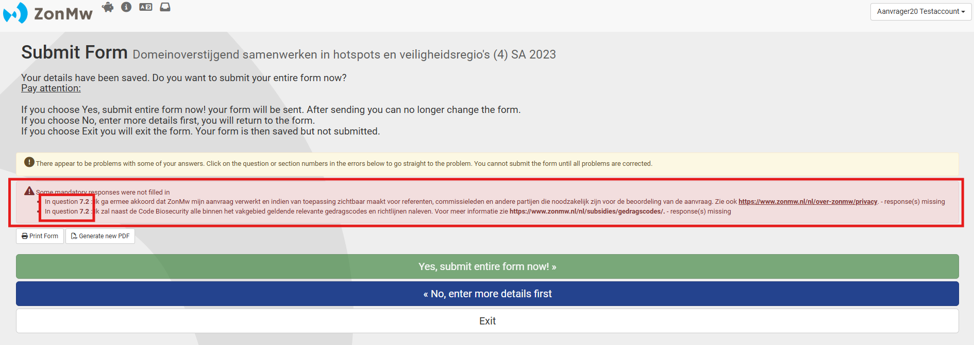
Figure 10: Form with uncompleted, compulsory fields.
- Click on if you do not want to submit the application yet and wish to continue working on it at a later time. The application will be saved in your inbox.
- To export the entire application form with completed text to PDF, click on ‘Generate new PDF’.
Please note: uploaded attachments are not visible in this PDF.

After submitting your application, you will be directed to your inbox, where you will see the message
‘Your form was submitted successfully’ (Figure 11). You will receive an automatic email as
confirmation of receipt after submitting your application.
Please note: if you submitted your application after the submission deadline, the confirmation of receipt will indicate that your application was submitted after the deadline and will not be processed.

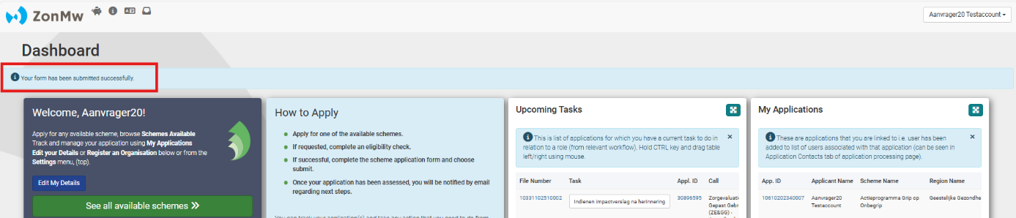
Figure 11: Notification in your inbox of successful submission of your application.

You can find your submitted applications in 'My Applications' (Figure 12).

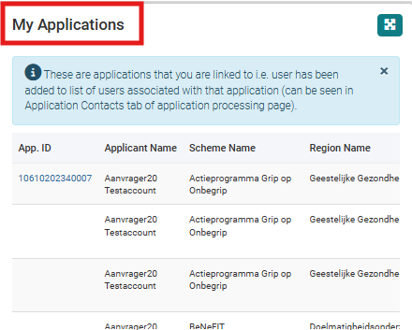
Figure 12: My Applications.

After the submission deadline, all applications will be examined by ZonMw.
- If your project idea or grant application is temporarily declared inadmissible, you will receive an email with information as to why the application does not meet the submission requirements as indicated in the grant call. For this purpose, the application in My ZonMw will be reopened. When you log in, the following task will be ready in your inbox 'Prepare project idea/application'.
- If this concerns a project idea, you will receive positive or negative advice by email at the end of the assessment process. If the advice is positive, the next task will be ready in your inbox: 'Prepare application'.
- If this already concerns a grant application, the next step is ‘Prepare rebuttal'. You can read more about this in the next chapter.

3 Submitting your rebuttal
After you have submitted your application to ZonMw, the application will go through an assessment
process. If your application has been assessed by referees, you will have the opportunity to respond
to the assessments by submitting a rebuttal. You will receive an email from ZonMw setting out the
conditions of your rebuttal. A task will be placed in your inbox in My ZonMw.
- Logging in to My ZonMw and click on the task in your inbox ‘Wederhoor opstellen en indienen/ Prepare rebuttal’ (Figure 13).

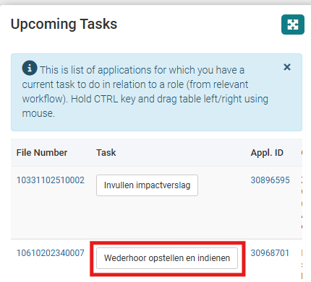
Figure 13: Inbox with task to prepare rebuttal.
You will be directed to the screen ‘Wederhoor opstellen en indienen/ Prepare rebuttal’ (Figure 14). Under the ‘Documents’ tab you will find the application documentation, such as the completed application form and attachments. You will find the referees’ assessments in the ‘Generated PDF’ or ‘Samengestelde_PDF’ file.
- You can click on this file to view the referees’ assessments.
- Now click on the ‘Wederhoor formulier/ Applicant’s Rebuttal’ button on the right of the screen under ‘To do’.

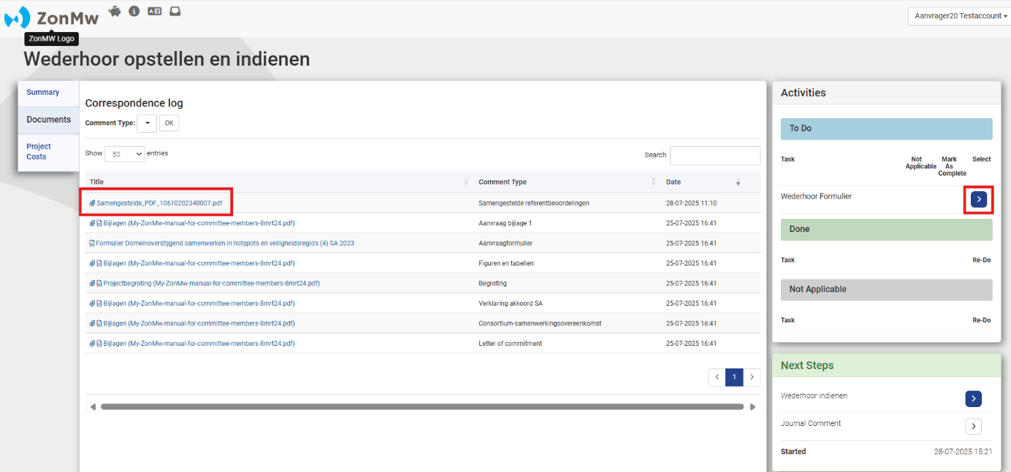
Figure 14: Submit rebuttal screen with documents on the left and tasks to be completed on the right.
This will take you to the ‘Wederhoor formulier/ Rebuttal Form’ (Figure 15).
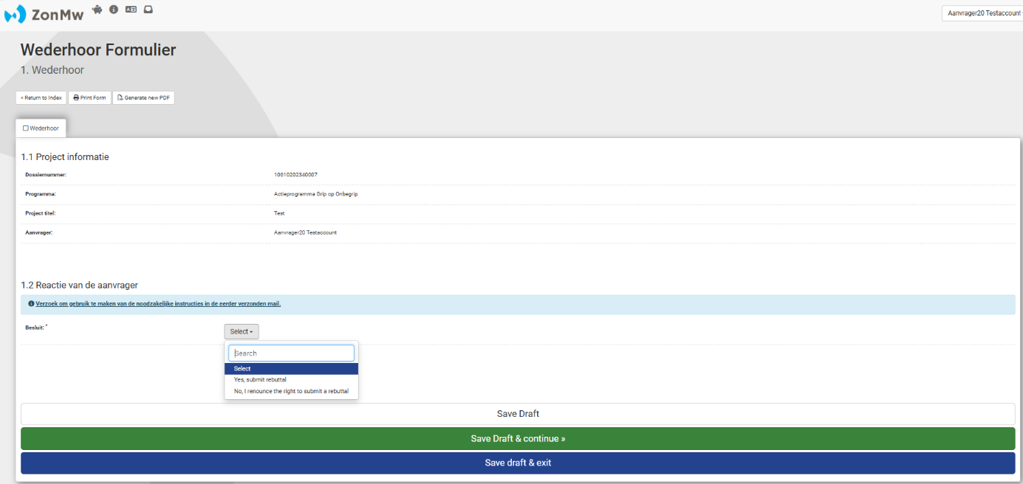
Figure 15: Rebuttal Form
- Please indicate under ‘Applicants Decision’ whether you want to make use of the possibility to submit a rebuttal. You can either select ‘Yes, submit rebuttal’ or ‘No, I renounce the right to submit a rebuttal’ (Figure 15).
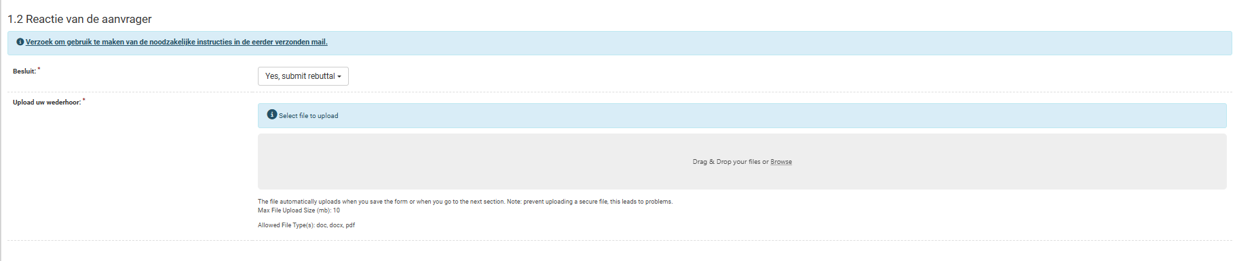
Figure 16: Uploading the rebuttal
If you have indicated that you want to submit a rebuttal, the option to upload your rebuttal in PDF
format will appear in My ZonMw (Figure 16). You can delete the file afterwards by clicking on the
‘Remove’ button (Figure 17).
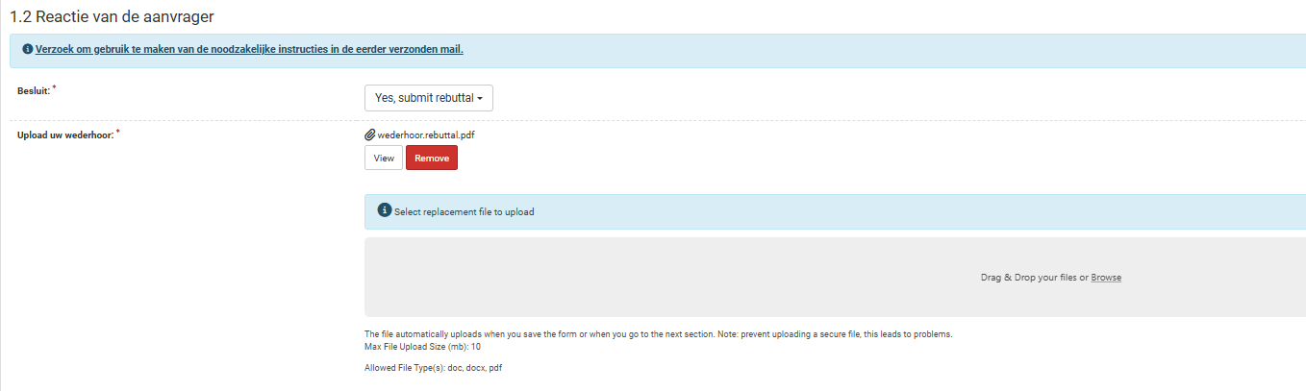
Figure 17: Removing the rebuttal.
Click on ‘Save & send’ and then on to submit the rebuttal (Figure 18). You
can use to return to the rebuttal form to make any modifications. You can save
the rebuttal with and complete it later. The task will then remain in the inbox
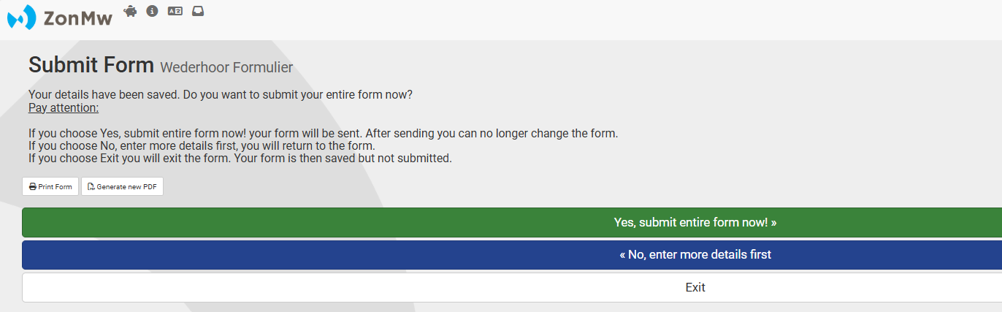
Figure 18: Submitting the rebuttal.

When you have submitted the rebuttal, the task will disappear from your inbox. You can find your
rebuttal in the application file under 'My Applications'. The rebuttal form can be found under
the ‘Documents’ tab in the application file. You will also receive confirmation of submission of the
rebuttal by email.

After this, the rest of the application process takes place. At the end of this process you will receive a letter communicating the decision (grant approval or rejection) by email. Even after this decision, you can find your project under 'My Applications'. More information about what is expected during the course of your awarded project can be found in the 'My ZonMw manual for project leaders'.

- END OF THIS MANUAL -

